# Introduction

## Introduction

The project titled **"PIXTREAM"** is a visionary social media platform that seeks to revolutionize the way people connect, share, and express themselves in the digital age. As a hub of creativity and interaction, Pixtream aims to empower users to showcase their talents and ideas through a diverse array of multimedia content while fostering meaningful relationships within a vibrant community. In a world increasingly driven by digital communication and innovation, the significance of platforms that prioritize user engagement, creative freedom, and accessibility cannot be overstated. This initiative is dedicated to addressing the evolving needs of content creators, influencers, and social enthusiasts by providing an ecosystem where simplicity meets functionality. Pixtream is not just a platform for posting photos and videos; it is a space where ideas converge, passions thrive, and individuals can curate their unique identities. By offering advanced features such as intelligent recommendations, detailed content categorization, and robust privacy controls, Pixtream ensures that every user has the tools they need to engage, discover, and grow. At its core, Pixtream is committed to enhancing the user experience by blending innovation with inclusivity. It is designed to adapt to diverse interests, enabling users to share their stories, explore global cultures, and build lasting connections. As we delve into the realms of creative expression and technological advancement, our mission is to provide a transformative platform that goes beyond social interaction, fostering a global community of thinkers, creators, and dreamers. Pixtream aspires to redefine the standards of social media by embracing the principles of creativity, collaboration, and accessibility. It is more than a digital space—it is a journey toward realizing potential, sharing experiences, and shaping the future of online engagement. With a focus on intuitive design and comprehensive support, Pixtream stands poised to be a cornerstone in the digital lives of millions, empowering them to connect, inspire, and excel on a global stage.

## Problem statement

In today’s digital landscape, social media platforms have become central to how people connect, share ideas, and express creativity. However, the existing platforms often fail to address the diverse needs of their user base effectively. These limitations hinder the potential for meaningful interaction, creative freedom, and community growth. Users face challenges in protecting their privacy, discovering relevant content, and finding like-minded individuals. Additionally, content creators struggle with a lack of visibility and limited tools to organize their work efficiently. These shortcomings not only diminish user satisfaction but also restrict the overall potential of social media as a medium for creativity and connection.

Pixtream seeks to fill this void by providing a user-censstric platform that overcomes these challenges. By introducing enhanced privacy controls, intelligent content categorization, and dynamic recommendation systems, Pixtream offers a solution that fosters creativity, encourages meaningful interactions, and builds an inclusive online community. The project aims to redefine the standards of social media, ensuring that users can express themselves freely, connect authentically, and explore content that truly resonates with their interests.

## Scope and relevance of the project

The scope of Pixtream extends beyond traditional social media functionalities, offering a comprehensive platform that caters to both individual users and content creators. By integrating advanced features such as detailed content categorization, privacy controls, and personalized user recommendations, Pixtream creates an inclusive environment for users to express their creativity, build meaningful connections, and engage with diverse communities.

### Scope:

* **Global Connectivity:** Pixtream provides users with the ability to connect with individuals worldwide, fostering a vibrant and diverse user base.
* **Creative Expression:** A dedicated space for sharing multimedia content, including photos, videos, music, and more, categorized into detailed themes and subcategories.
* **Enhanced Interaction:** Tools such as likes, comments, shares, and private messaging create a dynamic and engaging experience for users.
* **Robust Administration:** Features for addressing complaints, handling reports, and maintaining a safe and respectful community.

### Relevance:

In an era where digital platforms shape social and cultural interactions, Pixtream is positioned as a relevant solution to existing gaps in the social media ecosystem. It addresses the rising demand for personalized content discovery, secure interactions, and tools that enable users to explore and showcase their creativity. By prioritizing user satisfaction and adaptability, Pixtream aligns with the evolving needs of a digitally connected world, ensuring it remains a valuable tool for both social and creative endeavors.

## Objectives

* + - Academic

Enrichment Provide students with the opportunity to access courses and academic programs not available at their home institutions. Foster a global perspective by exposing students to diverse teaching methods, curriculum structures, and academic environments.

* + - Personal Development

Foster personal growth and independence by challenging students to adapt to new and unfamiliar situations. Encourage self-reflection and the development of resilience, adaptability, and problem-solving skills.

* + - Professional and career development

Provide opportunities for internships, research projects, or networking events to enhance students’ professional skills and build a global professional network. Support students in gaining a competitive edge in the job market by demonstrating cultural awareness, adaptability, and international experience.

# System Analysis

## Introduction

In the realm of study abroad agencies, systems analysis entails scrutinizing the needs and functionalities of the agency’s website, enabling the evaluation, modeling, and selection of a coherent strategy for its development. The initiation of study abroad agency website projects may stem from diverse motives, such as resolving specific challenges, leveraging opportunities, or aligning with stakeholder directives. The primary individuals engaged in this process comprise educational consultants, sponsors, and enthusiastic prospective students seeking international educational experiences.

## Existing system

The existing system in a study abroad agency encompasses the operational framework and processes currently in place to facilitate the provision of study abroad services to students. This system typically includes various components and procedures designed to assist students in their pursuit of international education.

### Limitation of existing system

One of the main Limitation of existing, Some students may find that utilizing the services of a study abroad agency adds an extra layer of cost to their international education endeavors. This can be a limiting factor for students with budget constraints, potentially leading them to explore alternative approaches to studying abroad.

The range of services offered by study abroad agencies may vary, and some agencies may have limitations in terms of the breadth and depth of support they can provide. This could result in students needing to seek additional resources or support from other sources to address specific aspects of their study abroad plans.

## Proposed system

The proposed system is designed to eliminate all the disadvantages of the existing one. It is designed keeping in mind all the drawbacks of the present system in order to provide a solution to the existing system.

### Advantages of proposed system

* + - It reduces Paper work
    - Better communication among customers
    - Saves time for decision making
    - Saves Customers Money
    - Inform up-to-date information

## Feasibility study

A feasibility study for a study abroad website project involves assessing the viability and potential success of developing and operating a website focused on Higher Education in foreign country -related activities. A feasibility study is carried out to select the best system that meets performance requirements. The main aim of the feasibility study activity is to determine whether it would be financially and technically feasible to develop the product. The feasibility study activity involves the analysis of the problem and collection of all relevant information relating to the product such as the different data items which would be input to the system, the processing required to be carried out on these data, the output data required to be produced by the system as well as various constraints on the behavior of the system. It is a test of a system proposal according to its workability, impact on the organization, ability to meet user needs and effective use of resources. The objective of a feasibility study is not to solve the problem but to acquire a sense of its scope.

### Technical feasibility

Technical feasibility in a study abroad website project refers to the assessment of the

project’s technical requirements, infrastructure, and capabilities. It involves evaluating

whether the proposed website can be developed and operated effectively from a technical standpoint. The technical feasibility study is a study of function, performances and constraints and improve the ability to create an acceptable system. Technical feasibility is frequently the most difficult are to achieve at the stage of product engineering process. The system must be evaluated from technical viewpoint first. The assessment of this feasibility must be based on the outline design of the

system requirements in the terms of inputs, outputs program procedure and staffs. This project is said to be technically feasible. Technical feasibility centers on the existing computer systems and extend to which it can support the proposed system. This involves financial consideration to technical enhancements. This site is feasible with all aspects of technical.

### Operational feasibility

Operational feasibility in a sports website project refers to assessing the project’s ability to be effectively implemented and operated within the existing organizational and operational context. It focuses on evaluating whether the proposed website aligns with the available resources, capabilities, and processes of the organization. Assessing the organizational readiness involves evaluating the capabilities and resources available to support the development and operation of the tourism website. The purpose of the operational feasibility study is to determine the whether the new system will be used if it is developed and installed. And whether there will be resistance from users that will undermine the possible application benefit. The first challenge was whether the system meets the organizational requirements. This is checked by the system requirement collected from the users and the management and the operational feasibility proved that the system is capable to meet Its functional requirements. The developed system is completely driven and user friendly. In mental health prediction operational feasibility is dependent on human resources available for the project and involves projecting whether the system will be used if it is developed and implemented.

### Economic feasibility

Economic feasibility in a study abroad website project refers to the evaluation of the financial viability and profitability of the project. It involves analyzing the potential costs, revenue streams, and overall economic benefits associated with developing and operating the website. This involves estimating the costs associated with developing the study abroad website. It includes expenses such as website design and development, content creation, graphic design, hosting and infrastructure, software licenses, and any additional technical or consulting services required. A detailed cost

breakdown helps in assessing the initial investment required for the project. Economic analysis is the most frequently used method for evaluating the effectiveness of the proposed system. It evaluates whether the system benefits greater than cost. The proposed mental health prediction system is an effective one since the benefits of the software outweigh the cost incurred in installing it. It can be developed under optimal expenses with the available hardware and software. This site is economically feasible.

## Software engineering paradigm applied

In this project, incremental software development paradigm approach is used build the software, which means the entire project is divided into small part and each part is developed and delivered incrementally. The incremental is iterative in nature, allowing for the development of a functional product through successive cycles or incremental. The incremental software paradigm is particularly beneficial in projects where requirements are not well-defined initially, as it allows for flexibility and responsiveness to changing needs. It promotes early and continuous delivery of valuable functionality, reducing the time to market and increasing customer satisfaction.

# System Design

## Introduction

System design is the solution to the creation of a new system. This phase is composed of several systems. This phase focuses on the detailed implementation of the feasible system. System design has two phases of development logical and physical design. During logical design phase the analyst describes inputs (sources), out puts (destinations), databases (data sores) and procedures (data flows) all in a format that meats the uses requirements. Design goes through the logical and physical stages of development. At an early stage in designing a new system, the system analyst must have a clear understanding of the objectives, which the design is aiming to fulfil. Second input data and master files (database) have to be designed to meet the requirements of the proposed output. The operational (processing) phases are handled through program construction and testing. The system design includes:

* + - Output design
    - Database design
    - Input design
    - Form design
    - Architectural design
    - System modules

## Database design

Data Base design is the logical form of design of data storage in the form of records in a particular structure in the form of tables with fields which is not transparent to the normal user but it actually acts as the backbone of the system. As we know database is a collection of which helps the system to manage and store data is called database management system. Data base management system builds some form of constraints like integrity constraints, i.e., the primary key or unique key and referential integrity which help to keep data structure storage and access of data from tables efficiently and accurately and take necessary steps to concurrent access of data and avoid redundancy of data in tables by normalization criterions. Normalization is the method of breaking down complex table structures into simple table structures by using certain rules thus reduce redundancy and inconsistency and disk space usage and thus increase the performance of the system or application which is directly linked to the

database design and also solve the problems of anomalies. There are different forms of normalization,

some are:

* + - First Normal form (1NF)
    - Second Normal form (2NF)
    - Third Normal form (3NF)

The database design of the new system is in Second normal form and every non-key attribute is functionally depends only on the primary key. The master and transaction tables and their structure are shown below.

## Table design

### Category

|  |  |  |  |
| --- | --- | --- | --- |
| **Field** | **Datatype** | **Constraint** | **Description** |
| Category_id | Int | PRIMARY KEY | Category id |
| Category_name | Varchar(30) | Not null | Category name |

1. **Country**

|  |  |  |  |
| --- | --- | --- | --- |
| **Field** | **Datatype** | **Constraint** | **Description** |
| Country_id | Int | PRIMARY KEY | Country id |
| Country_name | Varchar(30) | NOT NULL | Country name |
| Description | Varchar(550) | NOT NULL | Country description |
| image | Varchar(250) | NOT NULL | Country image |

### Course

|  |  |  |  |
| --- | --- | --- | --- |
| **Field** | **Datatype** | **Constraint** | **Description** |
| Course_id | Int | Primary key | Course id |
| Course_name | Varchar(50) | Not null | Course name |
| Duration | Int | Not null | Course duration |
| Syllabus | Varchar(255) | Not null | Syllabus |
| Eligibility | Varchar(50) | Not null | Eligibility |
| Criteria | Varchar(100) | Not null | Criteria |
| Status | Varchar(30) | Not null | Course status |
| Amount | Int | Not null | Course fee |
| University_id | Int | Foreign key | It reference the university _id  from University |
| Country_id | Int | Foreign key | It reference the country_id from Country |
| Category_id | Int | Foreign key | It reference the category_id from Category |

1. **Feedback**

|  |  |  |  |
| --- | --- | --- | --- |
| **Field** | **Datatype** | **Constraint** | **Description** |
| F_id | Int | Primary key | Feedback id |
| Type | Varchar(20) | Not null | Feedback type |
| Message | Varchar(250) | Not null | Message |
| User_id | int | Foreign key | It reference the user_id from User |

### Image

|  |  |  |  |
| --- | --- | --- | --- |
| **Field** | **Datatype** | **Constraint** | **Description** |
| Image_id | Int | Primary key | Image id |
| Image_name | Varchar(255) | Not null | Image name |
| Image_type | Varchar(20) | Not null | Image type |
| description | Varchar(40) | Not null | description |

1. **Payment**

|  |  |  |  |
| --- | --- | --- | --- |
| **Field** | **Datatype** | **Constraint** | **Description** |
| Pay_id | Int | Primary key | Payment id |
| Card_number | Varchar(16) | Not null | Card number |
| Expiry_date | Varchar(5) | Not null | Card expiry date |
| Cvv | Int | Not null | Cvv |
| Card_holder_name | Varchar(40) | Not null | Card holder name |
| Transaction_amount | Varchar(6) | Not null | Transaction amount |
| Process_time | Time | Not null | Process time |
| User_id | Int | Foreign key | It reference the usr_id from User |
| Course | Int | 0 | Course paid |
| status | Int | 1 | status |

### Profile

|  |  |  |  |
| --- | --- | --- | --- |
| **Field** | **Datatype** | **Constraint** | **Description** |
| Profile_id | Int | Primary key | Profile id |
| Fname | Varchar(20) | Not null | First name |
| Lname | Varchar(20) | Not null | Last name |
| Dob | Date | Not null | Date of birth |
| Gender | Varchar(7) | Not null | Gender |
| Email | Varchar(30) | Not null | Email address |
| Phone | char(10) | Not null | Phone number |
| Passport_number | Varchar(20) | Not null | Passport number |
| University | Varchar(40) | Not null | University |
| College | Varchar(100) | Not null | College |
| Course | Varchar(30) | Not null | Course |
| Percentage | Varchar(5) | Not null | Percentage |
| Certificate | Varchar(550) | Not null | Certificate |
| User_id | int | Foreign key | It reference the user_id from User |

1. **University**

|  |  |  |  |
| --- | --- | --- | --- |
| **Field** | **Datatype** | **Constraint** | **Description** |
| University_id | Int | Primary key | University id |
| University_name | Varchar(20) | Not null | University name |
| Location | Varchar(50) | Not null | University location |
| Uimage | Varchar(255) | Not null | University image |
| Country_id | Int | Foreign key | It reference the courty_id from Country |

1. **User**

|  |  |  |  |
| --- | --- | --- | --- |
| **Field** | **Datatype** | **Constraint** | **Description** |
| User_id | Int | Primary key | User id |
| username | Varchar(30) | Not null | Username |
| Phone | Char(10) | Not null | Phone number |
| Email | Varchar(30) | Not null | Email address |
| Dob | Date | Not null | Date of birth |
| Password | Varchar(30) | Not null | Account password |
| User_type | Varchar(10) | User | User type |
| Profile_pic | Varchar(550) | Not null | Profile picture |

## Object Oriented Design-UML diagrams

UML stands for Unified Modelling Language. UML is a language for specifying, visualizing and documenting the system. This is the step while developing any product after analysis. The goal from this is to produce a model of the entities involved in the project which later need to be built. The representation of the entities that are to be used in the product being developed need to be designed. Software design is a process that gradually changes as various new, better and more complete methods with a broader understanding of the of the whole problem in general come into existence. There are various kinds of methods in software design. They are as follows:

* Use case diagram
* Activity diagram
* Sequence diagram
* Class diagram

### Use case Diagrams:

Use case diagrams model behavior within a system and helps the developers understand of what the user require. The stick man represents what’s called an actor. An actor represents an outside entity- either human or technological. Use case diagrams can be useful for getting an overall view of the system and clarifying who can do and more importantly what they can’t do. Use case Diagram consists of use cases and actors and shows the interaction between the use case and actors. The

purpose is to show the interactions between use cases and actor. To represent the system requirements from user’s perspective. It must be remembered that the use- cases are the functions that are to be performed in the module. An actor could be the end-user of the system or an external system.

### Activity Diagram:

The purpose is to show the activities which the users performed. Actives are shown parallel and sequentially in which order they are performed. Some activities are joined and split according to its flow. Flow of data is represented using arrows.

### Sequence Diagram:

The purpose is to show the sequential flow through of activities. In other Words, we call it mapping processes in terms of data transfers from the actor through corresponding objects. To represent the logical flow of data with respect to a process. It must be remembered that the sequence diagram display objects and not the classes. **Class Diagram:**

This is one of the most important of the diagrams in development. The diagram breaks the class into three layers. One has the name, the second describes its attributes and the third its methods. The private attributes are represented by a padlock to left of the name. The relationships are drawn between the classes. Developers use the Class Diagram to develop the classes. Analyses use it to show the details of the system. Architects look at class diagrams to see if any class has too many functions and see if they are required to be split.

### Use case Diagram

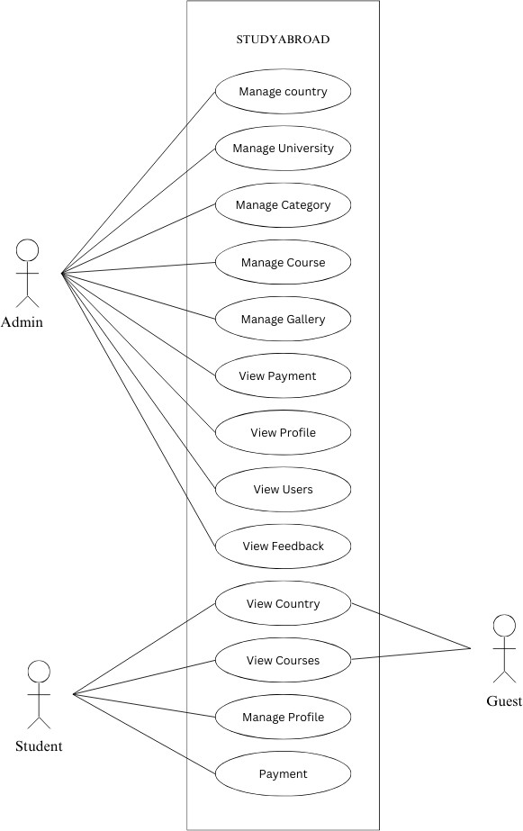

**Activity diagram of Admin**

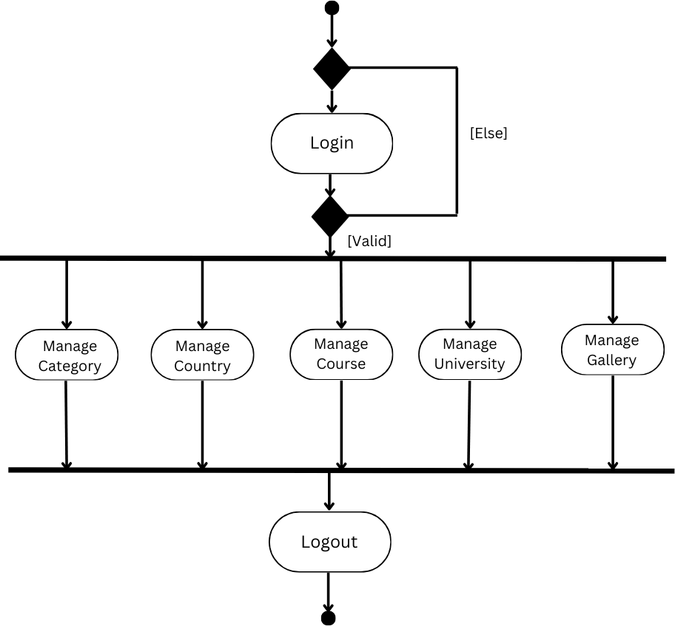

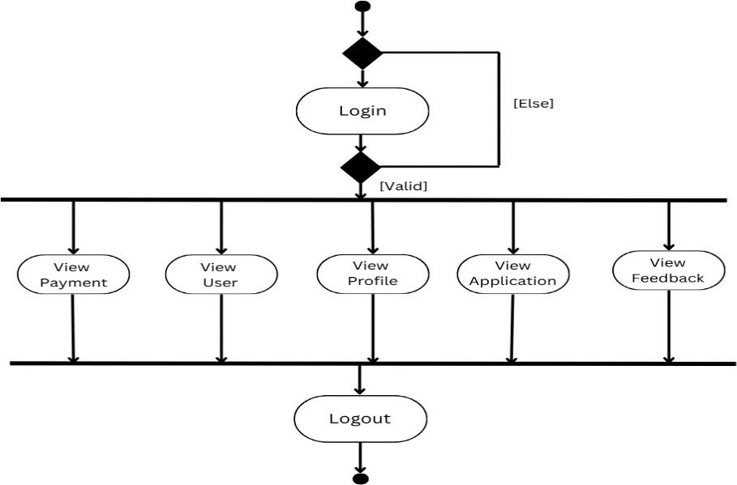

### Activity diagram of Customer

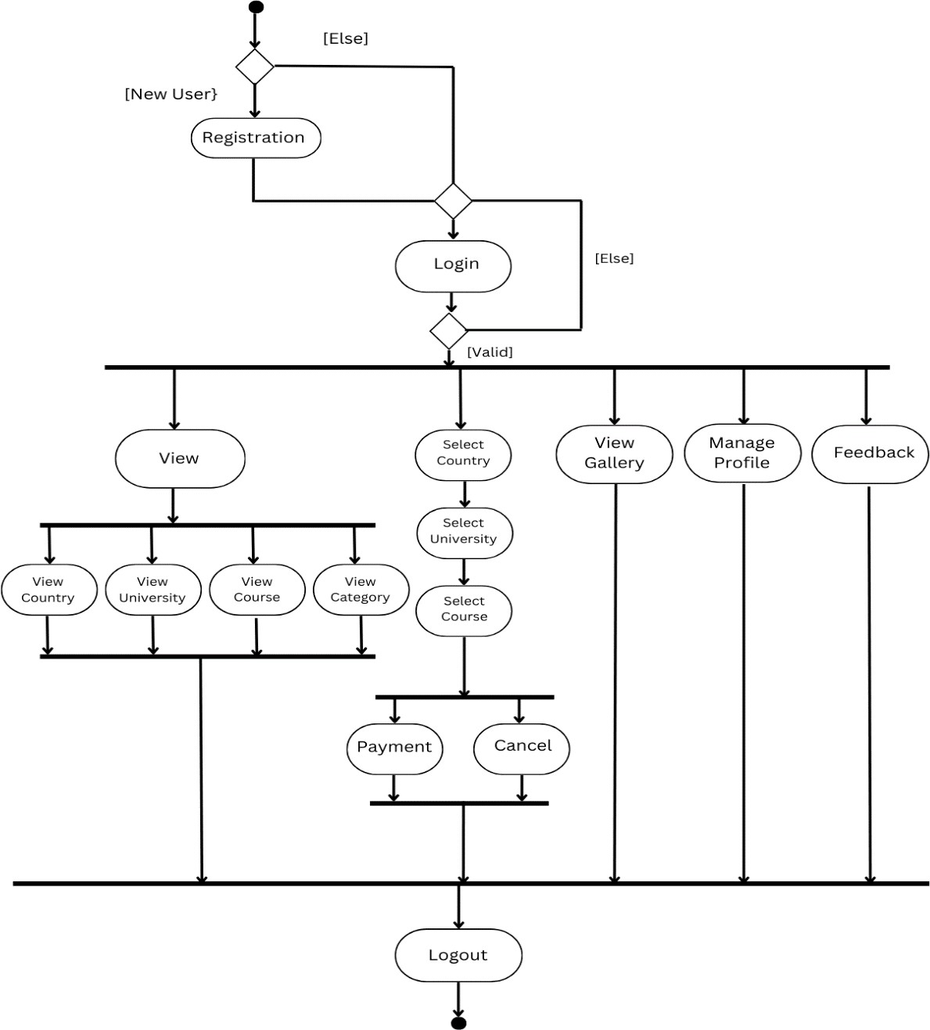

**Activity diagram of Guest user**

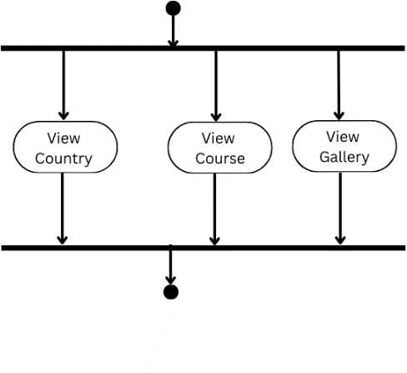

### Sequence diagram of admin

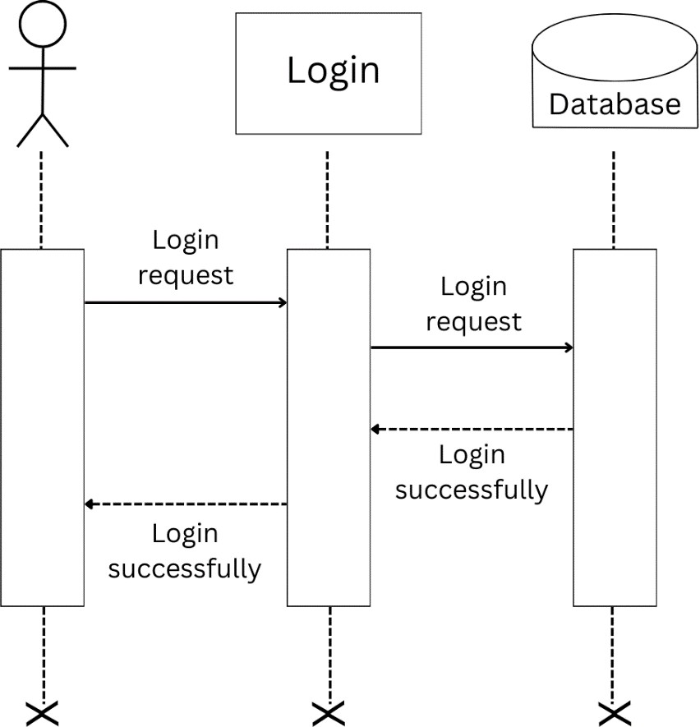

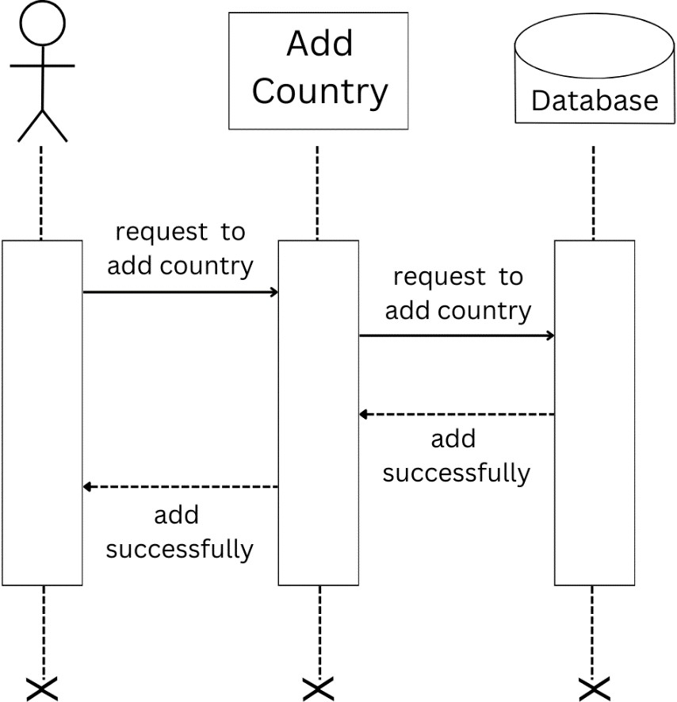

**Sequence diagram of Student**

### Course Selection

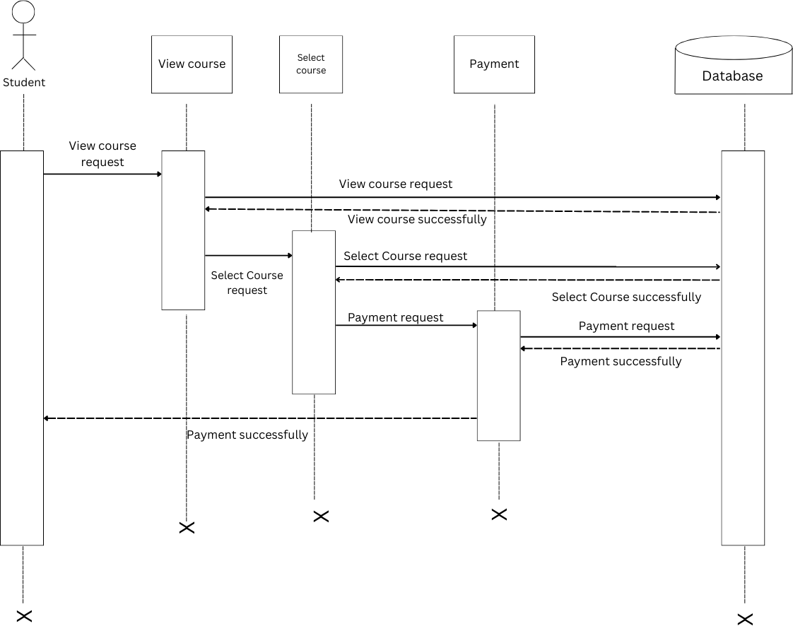

1. **Profile**

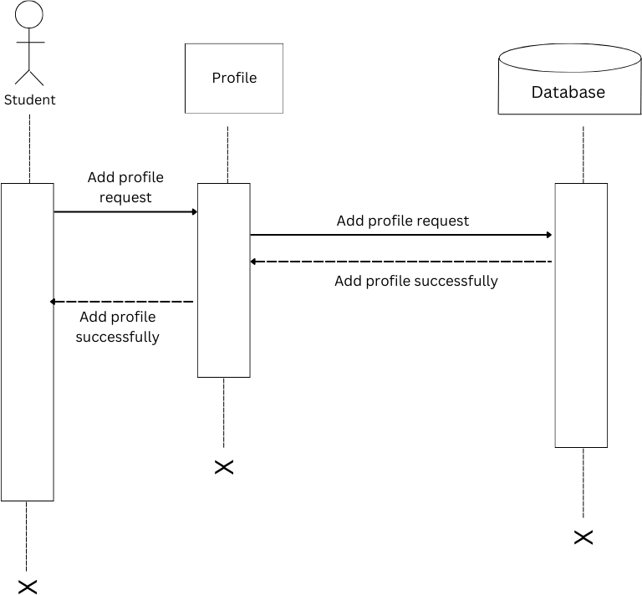

### Sequence diagram of Guest

* 1. **View Country**

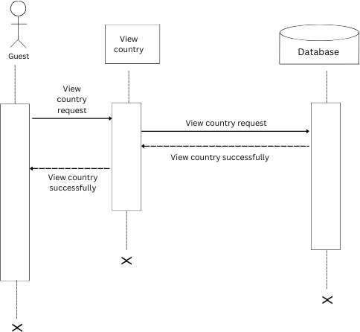

### View Course

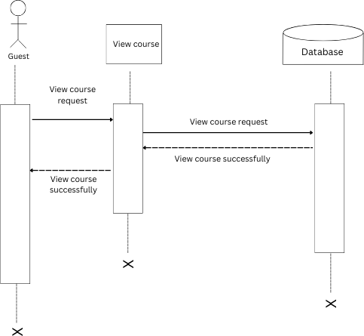

**Class Diagram**

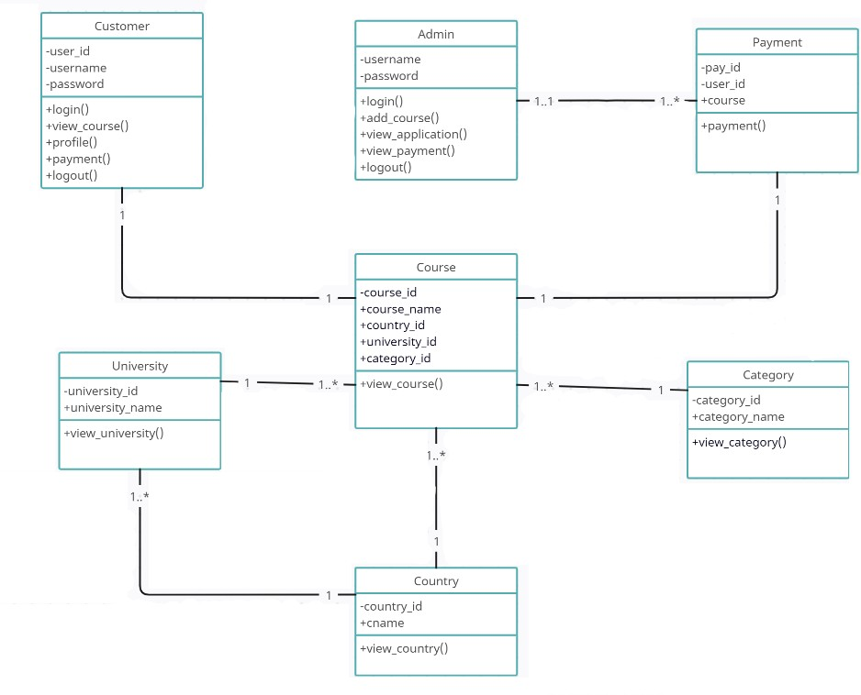

### 5.4 MODULES DESCRIPTION

A software system is always divided into several sub systems that makes it easier for the development. A software system that is structured into several subsystems makes it easy for the development and testing. The different subsystems are known as the modules and the process of dividing an entire system into subsystems is known as modularization or decomposition. The system under consideration has been divided into several modules taking in consideration the above-mentioned criteria. Modules are

### Admin

Admin is the core part of this project. He is the person who has the full control over the system, it could be an owner or a employee employed by owner. He manages courses details offered by different universities spread across the world. Also he

updates events and Blog etc. Other service carried out by him are payments, feedback, enquiry etc.

## Student

Customer is the End User who registered into the project. He can choose course as his eligibility criteria satisfies and then by making payment. Other privileges for customer are, they can view blog, gallery, post reviews & feedbacks, assistance and paper preparation

## Guest

Guest is normally an End user but it has less accessibility in the services offered. They can become a customer by registration & payment, then access services offered etc.

## Input design

The input design is the link between the information system and the user. It comprises the developing specification and procedures for data preparation and those steps are necessary to put transaction data into a usable form for processing data entry. The activity of putting data into the computer for processing can be achieved by inspecting the computer to read data from a written or printed document or it can occur by having people keying the data directly into the system.

* + - What data should be given as input?
    - The dialogue to guide the operating personnel in providing input.
    - Methods for preparing input validations and steps to follow when error Occur.

### Login

This feature used by the all the users to login into system. Users required username and password.

### Registration

This form is used by the customers to register to the system.

### Add country, course & university

These forms are used by Admin to store & manage details course.

### Gallery

This form is used to provide information to customers.

## Output design

Computer output is the most important and direct information source to the user. Output design is a process that involves designing necessary outputs in the form of reports that should be given to the users according to the requirements. Efficient, intelligible output design should improve the system’s relationship with the user and help in decision making. So, while designing output the following things are to be considered.

* Determine what information to present
* Arrange the presentation of information in an acceptable format
* Decide how to distribute the output to intended receipts.

### View user

The admin of Agency can view the user which joined by registration.

### View Applications

Admin also view the applications submitted by Customers needed to process their application.

### View Course & Country

Admin can add course and country details and mange it up-to-date for giving the best service.

# System Environment

## Introduction

It encompasses the hardware, software, data, personnel, and networks that collectively create the context within which a software system operates. Understanding and carefully managing the system environment is essential for ensuring optimal performance, reliability, and scalability of the software. This introduction provides an overview of the significance of the system environment in the realm of software projects.

## Software requirement specification

Operating System : Microsoft Windows 11 Home Single Language Front End : PHP, HTML, JavaScript,CSS

Back End : MySQL Server : Apache

Software Used : Visual Studio Code, WAMP

## Hardware requirements specification

Processor : Intel(R) Core(TM) i7-10510U Primary : 512.0MB RAM or Higher Secondary : 2.0GB hard disc or higher Monitor : CRT or TFT or higher Keyboard : 104 K

Pointing device : 2 or 3 button mouse

Printer : Dot Matrix or Ink Jet or Laser Printer

## Tools, Platforms Front end tool

The front-end of an application is distinctly human. It’s what the user sees, touches and experiences. In this respect, empathy is a required characteristic of a good front- end developer. The front-end of an application is less about code and more about how a user will interpret the interface into an experience. That experience can be the difference between a billion-dollar company and complete collapse. If you were a

Myspace user in 2004, you were probably content with the experience. But once you started to use Facebook, you almost certainly had a better experience. You realized that you could socialize with a simpler design, no flashing banner ads, easy-to-find friends, etc. Facebook and Myspace had a lot of differences under the hood as well (back-end), but at least part of Facebook’s triumph can be attributed to a better front- end and user experience.

The technologies used in front-end development commonly include:

**HTML** – All code in a web application is eventually translated to HTML. It’s the

language that web browsers understand and use to display information to users. A web developer’s understanding of HTML is analogous to a carpenter’s understanding of a screwdriver. It’s so important and necessary that it’s often assumed for employment.

**CSS** – By itself, HTML is quite plain. HTML does provide some basic style options,

but to build a good front-end, developers must have experience with CSS. CSS provides the paint, templates, glitter, buttons, tassel, lights, and many other things that can be used to improve the presentation of a web page. CSS is so commonly used that languages have been built to make writing CSS easier. These languages – like Sass and LESS – are also known as CSS pre-compilers, but they are simply used to write more efficient and manageable CSS code.

**JavaScript** – If you could only learn one language in your lifetime, you’d be well advised to choose JavaScript. Though it’s not exclusively a front-end language, that’s where it’s most commonly used. JavaScript is a language that is run on a client machine, i.e., a user’s computer. This means that JavaScript can be used to program fast, intuitive and fun user experiences, without forcing a user to refresh their web page. Drag-and drop, infinite-scroll and videos that come to life on a web page can all be programmed with JavaScript. JavaScript is so popular that entire frameworks have been built just to make building application front-ends easier. Frameworks like Angular, Ember, React and Backbone are all very widely used for JavaScript-heavy front-ends.

## Back end tool

The back-end of a web application is an enabler for a front-end experience. An application’s front-end may be the most beautifully crafted web page, but if the application itself doesn’t work, the application will be a failure. The back-end of an application is responsible for things like calculations, business logic, database interactions, and performance. Most of the code that is required to make an application work will be done on the back-end. Back-end code is run on the server, as opposed to the client. This means that back-end developers not only need to understand programming languages and databases, but they must have an understanding of server architecture as well. If an application is slow, crashes often, or constantly throws errors at users, it’s likely because of back-end problems.

### PHP

PHP is an acronym for "PHP: Hypertext Pre-processor". PHP is a widely-used, opensource scripting language. PHP scripts are executed on the server. PHP is free to download and use. PHP is an amazing and popular language. It is powerful enough to be at the core of the biggest blogging system on the web. It is deep enough to run the largest social network. It is also easy enough to be a beginner’s first server-side language files can contain text, HTML, CSS, JavaScript, and PHP code. PHP code are executed on the server, and the result is returned to the browser as plain HTML. PHP files have extension ".php". PHP can generate dynamic page content. PHP can create, open, read, write, delete, and close files on the server. PHP can collect form data. PHP can send and receive cookies. PHP can add, delete, and modify data in your database. PHP can be used to control user-access. PHP can encrypt data. With PHP you are not limited to output HTML. You can output images, PDF files, and even flash movies. You can also output any text, such as XHTML and XML.

### MYSQL

MySQL is the most popular Open-Source Relational SQL Database Management System. MySQL is one of the best RDBMS being used for developing various based software applications. MySQL is developed, marketed and supported by MySQL AB, which is a Swedish company. This tutorial will give you a quick start to MySQL and make you comfortable with MySQL programming.

### WAMPSERVER

WampServer is a Web development platform on Windows that allows you to create dynamic Web applications with Apache2, PHP, MySQL and MariaDB. WampServer automatically installs everything you need to intuitively develop Web applications. You will be able to tune your server without even touching its setting files.

## Operating system

### WINDOWS 11

Windows 11 is the latest major release of Microsoft's Windows NT operating system, released in October 2021. It is a free upgrade to its predecessor, Windows 10 (2015), and is available for any Windows 10 devices that meet the new Windows 11 system requirements. Windows 11 features major changes to the Windows shell influenced by the cancelled Windows 10X, including a redesigned Start menu, the replacement of its "live tiles" with a separate "Widgets" panel on the taskbar, the ability to create tiled sets of windows that can be minimized and restored from the taskbar as a group, and new gaming technologies inherited from Xbox Series X and Series S such as Auto HDR and Direct Storage on compatible hardware. Internet Explorer (IE) has been replaced by the Chromium-based Microsoft Edge as the default web browser, like its predecessor, Windows 10, and Microsoft Teams is integrated into the Windows shell. Microsoft also announced plans to allow more flexibility in software that can be distributed via the Microsoft Store and to support Android apps on Windows 11 (including a partnership with Amazon to make its app store available for the Function). Citing security considerations, the system requirements for Windows 11 were increased over Windows 10. Microsoft only officially supports the operating system on devices using an eighth-generation Intel Core CPU or newer (with some minor exceptions), a second-generation AMD Ryzen CPU or newer, or a Qualcomm Snapdragon 850 ARM system-on-chip or newer, with UEFI secure boot and Trusted Platform Module (TPM) 2.0 supported and enabled (although Microsoft may provide exceptions to the TPM 2.0 requirement for OEMs). While the OS can be installed on unsupported processors, Microsoft does not guarantee the availability of updates. Windows 11 removed support for 32-bit x86 CPUs and devices that use BIOS

firmware. Windows 11 received a mixed reception at launch. Pre-release coverage of the operating system focused on its stricter hardware requirements, with discussions over whether they were legitimately intended to improve the security of Windows or as a ploy to upsell customers to newer devices and over the e-waste associated with the changes. Upon release, it was praised for its improved visual design, window management, and stronger focus on security, but was criticized for various modifications to aspects of its user interface that were seen as worse than its predecessor, as an attempt to dissuade users from switching to competing Applications.

# System Implementation

## Introduction

It is a critical phase in the software development life cycle where the designed system is put into action. It involves translating the specifications and plans developed during earlier stages into a functioning and operational software system. This process encompasses the actual coding, configuration, testing, and deployment of the software. In this introduction, we will delve into the significance of system implementation and provide a general description of the key activities involved.

## Coding Sample codes Home page

<?php include "guestheader.php" ?>

<head>

</head>

<body>

<div class="main">

<div class="container-1">

<img src="../user/img/img.jpg" alt="Sample Image">

<div class="text-overlay"><p>Study Abroad</p></div>

<div class="text-overlay-1"><p><i>" We are here for your Dreams "</i></p></div>

</div>

<h1>Welcome to Our Website</h1>

<p>Study Abroad is a top Leading Study Abroad Agency, Because we give the Best out of Best.</p>

<button>Learn More</button>

<h1>Countries</h1>

<?php

include "../user/dbconnect.php";

// Fetching data from the table

$query = "SELECT country_name,country_id , image FROM country";

$result = mysqli_query($conn, $query);

// Displaying the data in HTML

while ($row = mysqli_fetch_assoc($result)) { echo '<div class="country" id="country">'; echo "<h2>" . $row['country_name'] . "</h2>";

echo "<img src='../uploads/" . $row['image'] . "' alt='" . $row['country_name'] . "'

/>";

echo "</a>";

echo '</div>';

}

mysqli_close($conn);

?>

</div>

<div class="containe-about">

<h1 style="padding-top:30px;">About Us</h1>

<div class="image-container">

<img src="../user/img/img.jpg" alt="Company Logo">

</div>

<div class="info-container">

<p>ORION Study Abroad Pvt. Ltd, established in the year 2023 is one of the best study abroad consultants, headquartered in Kochi, Kerala, India , headed by its founder and Managing Director Mr. Ajay Babu an astute businessman, illustrious Author, Blogger,

philanthropist social worker and sports administrator.The company offers end to end study abroad facilitation services. It’s the authorized representative of 600+ top-notch Universities/ Colleges from over 20+ countries, with branches and associate offices in virtually all districts/

cities of Kerala and key Indian cities. The brand today has become synonymous with quality and reliability for hand -holding students wishing to study abroad in the best of overseas educational institutions across the globe, paving the way to phenomenal international academic success and

rewarding careers for thousands of students which has earned unwavering trust and patronage of students and parents alike.</p>

<p>Complementing the management is a team of highly trained motivated professionals with years of experience and skill with international exposure . Team StudyAbroad owes its success to the unwavering dedication, ethics, professional practices, continuous investment in staff training, the use of

state of the art technology, and above all to its ‘’client first’’ policy”.</p>

<p>Contact us at: [info@company.com</p](mailto:info@company.com)>

</div>

</div>

</div>

</body>

</html>

## Code validation and optimization

**Registration page**

<?php include "guestheader.php";?>

<html>

<head>

<style>

body {

font-family: Arial, sans-serif; background-color: #f2f2f2;

}

.reg-container { max-width: 400px; margin: 80px auto; padding: 20px; background-color: #fff; border-radius: 5px;

box-shadow: 0 0 10px rgba(0, 0, 0, 0.1);

}

h2 {

text-align: center; margin-bottom: 20px;

}

.row {

input[type="text"], input[type="number"],

input[type="password"], input[type="email"], input[type="date"] {

width: 95%; padding: 10px;

border: 1px solid #ccc; border-radius: 4px;

}

input[type="file"]{ display: block; width: 50%;

padding: 10px; background-color: grey; color: #fff;

text-align: center; font-weight: bold; text-decoration: none; border-radius: 4px;

transition: background-color 0.3s;

}

input[type="file"]:hover { background-color: orange; margin-bottom: 20px;

}

.btn_insert{ display: block; width: 30%; padding: 10px;

background-color: #4caf50; color: #fff;

text-align: center; font-weight: bold; text-decoration: none; border-radius: 4px;

transition: background-color 0.3s;

}

.btn_insert:hover { background-color: #45a049;

margin-bottom: 20px;

}

}

.col-md-6{ padding:10px;

}

</style>

<script src="src/validator.js">

</script>

</head>

<body>

<div class="reg-container">

<h2 class="row" >User Registraiton</h2>

<form action="" method="POST" enctype="multipart/form-data" >

<div class="row">

<div class="col-md-6">

<label>User Name </label>

<input type="text" name="uname" id="uname" >

<span id="unameError" style="color:red"></span><br>

</div>

</div>

<div class="row">

<div class="col-md-6">

<label>User Phone </label>

<input type="number" name="phone" id="phone" >

<span id="uphoneError" style="color:red"></span><br>

</div>

</div>

<div class="row">

<div class="col-md-6">

<label>User Email </label>

<input type="email" name="mail" id="mail" >

<span id="uemailError" style="color:red"></span><br>

</div>

</div>

<div class="row">

<div class="col-md-6">

<label>Date of Birth </label>

<input type="date" name="dob" id="dob" >

<span id="udobError" style="color:red"></span><br>

</div>

</div>

<div class="row">

<div class="col-md-6">

<label>Profile Photo </label>

<input type="file" name="uimg" id="uimg" >

<span id="upicError" style="color:red"></span><br>

</div>

</div>

<div class="row">

<div class="col-md-6">

<label>Password </label>

<input type="password" name="pass" id="pass" >

<span id="upassError" style="color:red"></span><br>

</div>

</div>

<div class="row">

<div class="col-md-6">

<label>Confirm Password </label>

<input type="password" name="cpass" id="cpass" >

<span id="ucpassError" style="color:red"></span><br>

</div>

</div>

<div class="row">

<div class="col-md-6">

<input type="submit" name="submit" id="submit" value="Submit" class="btn_insert" onclick="return validate()"><br>

</div>

</div>

</form>

</div>

</div>

<?php

include "../user/dbconnect.php"; if(isset($_POST["submit"]))

{

$uname = $_POST['uname'];

$phone = $_POST['phone'];

$email = $_POST['mail'];

$dob = $_POST['dob'];

$password = $_POST['pass'];

if (isset($_FILES['uimg'])) {

$imageName = $_FILES['uimg']['name'];

$imageTempName = $_FILES['uimg']['tmp_name'];

$uploadfileDirectory = 'profile/';

$imagePath = $uploadfileDirectory.$imageName; move_uploaded_file($imageTempName, $imagePath);

} else {

echo "<p>Profile photo not uploaded</p>";

}

$sql = "INSERT INTO user (username, phone, email, dob, password, user_type,profile_pic)

VALUES ('$uname', '$phone', '$email', '$dob', '$password','user','$imageName')";

// print_r($uname,$phone,$email,$dob,$password,$imageName); if (mysqli_query($conn, $sql)) {

echo "New record inserted successfully";

} else {

echo "Error: " . $sql . "<br>" . mysqli_error($conn);

}

mysqli_close($conn);

}

?>

</body>

</html>

# System Testing

## Introduction

System testing includes verification and validation. It is the major quality control measure employed during the software development. Testing a large system is a complex activity ,and so it is broken down into smaller activities .We have tested all the modules in our project separately .and run separately to detect coding errors if any. For this special test data are input for processing and the result are examined to ensure that the software does not fail. I.e. will run according to its specification and in away users expect. This is how we performed unit testing. due to its approach dynamic testing can only ascertain the presence of errors in the program; the exact nature of the error is not usually decided by testing. The reference documents for this process are the requirement document, and the goal is to see if the software meets the requirement documents. Testing here focuses on the external behavior of the system; the internal logic of the program is not emphasized. In “STUDY ABROAD” the entire system was divided into small modules and test separately i.e. each module was tested separately and then they were integrated and tested and finally the entire system was tested with live the data so as to find errors. The basic types of testing procedures are:

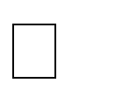Unit testing

Integration testing

Validation testing

Alpha testing

Beta testing

## Unit testing

This is the first level of testing. A unit testing focuses verification effort on the smallest unit of software design. This testing is carried out during the coding itself. In this testing step, each module is tested, for example in the registration password and login. Module interface is tested to ensure that the information properly flow and out of the program under test. Data consistency is tested to ensure that the data stored maintains its integrity during all steps in algorithm execution. All independent paths

are examined to ensure that all the statement in the module have been executed at least once.

## Integration Testing

Integration testing is a systematic test for constructing the program structure while conducting tests to uncover errors related to interfacing. The objective is to take unit tested modules and build a program structure that has been dictated by design. The data entered in the front end is successfully stored in the back end. For example, in the registration they entered username and password are successfully stored in the back end. This testing is conducted in the administrator module and user module.

## System testing

System Testing is a crucial phase in the software testing life cycle where the entire software system is tested as a whole to ensure that it meets the specified requirements. This testing phase comes after integration testing and before acceptance testing. The primary objective is to verify the functional and non-functional aspects of the system in an integrated environment.

By systematically testing the integrated system under various conditions, organizations can identify and rectify issues, ensuring a robust and reliable software product. Successful system testing contributes to a smoother acceptance testing phase and, ultimately, the successful deployment of the software.

# System maintenance

## Introduction

Even though the changeover of the system is fully correct and complete, it is not the end of the matter. The system should be given proper security and maintenance in order to keep them efficient and up-to-date.

## Maintenance

This software can be modified as need occurs. Maintenance includes all the activities after installation of the software that is performed to keep the system operational. The process of maintaining involves:

* Understanding the existing software
* Understand the effect of change
* Test for satisfaction

Maintenance can be done to this project by simply adding the new requirements that are the form of database the system can be modified. The maintenance process also helps to remove an error that raise in the system even after testing process. The complexity of the maintenance task coupled with the neglect of the maintenance concerns during development makes maintenance the most costly activity in life of the system project. The system security is for protection against fraud and disaster. To avoid unauthorized access, password protection is highly recommended while running this new system. The password has to be maintained directly and files have to be kept very confidential.

# Future enhancement and scope of further development

## Introduction

The developed system is feasible and changes can be made easily. The system is done with an insight into the necessary that be required in the future. Hence, the system can be maintained successfully without much rework. In the future the system can be further modified by including more features very easily.

## Merits of the system

Including more features very easily. The future trends and development that can occur with regard to this project have been taken into consideration while designing the project. The project is developed using PHP technology, which is the latest in the present scenario and hence upgrading the project would be easier in the future.

## Limitations of the system

The current system is limited with the service of education. Furthermore it can also helps for migration also. Also need to provide scholarship assistance for the students. It can’t provide financial assistance in case of educational loans etc.

## Future Enhancement of the system

We have tried our best to present the information effectively, yet there can be further enhancement in the application. We have taken care of all the critical aspects, which were needed to be taken care of. Because of fast changes in the world of programming this system will gradually get outdated and less effective. For the time being it’s possible to overcome problems by amendments and minor modifications to acknowledge the need of fundamental design. Though the new system provides base for improving the efficiency of operations, there are a lot of future enhancements that can be added to this project.

It can be extended in such a way that:

* + - Plane ticket Booking
    - Language training
    - Interview assistance

# Conclusion

### CONCLUSION

In the world computer are playing a vital role in the walks of life. In the field of medicine, industry, agriculture etc. computer is made unavoidable. Computerization is made to reduce the workload of every human being in the work filed and they also easily find errors and mistakes and they have very good chance for getting satisfaction by the way of clear results.

The project was successfully completed within the time span allotted. All the modules are tested separately and put together to form the main system. Finally, the system is tested with real data and it worked successfully. Thus, the system has fulfilled the entire objective defined.

I developed “Study Abroad” to overcome all the rising problems. We can keep the records effectively and accurate. It makes entire process online where the customers can register themselves, send request and panchayath can generate and view reports. More features can be enhanced.

# Bibliography

* Software Engineering (Third Edition), K K Aggarwal, Yogesh Singh, New Age International Publications.
* Software Engineering (7th Edition), Ian Sommerville, Pearson Education
* An Integrated approach to Software Engineering (Second Edition), Pankaj Jalote,
* [www.canva.com](http://www.canva.com/) for designing images
* [www.javatpoint.com](http://www.javatpoint.com/) for web designing

# Appendix

**Screenshorts**

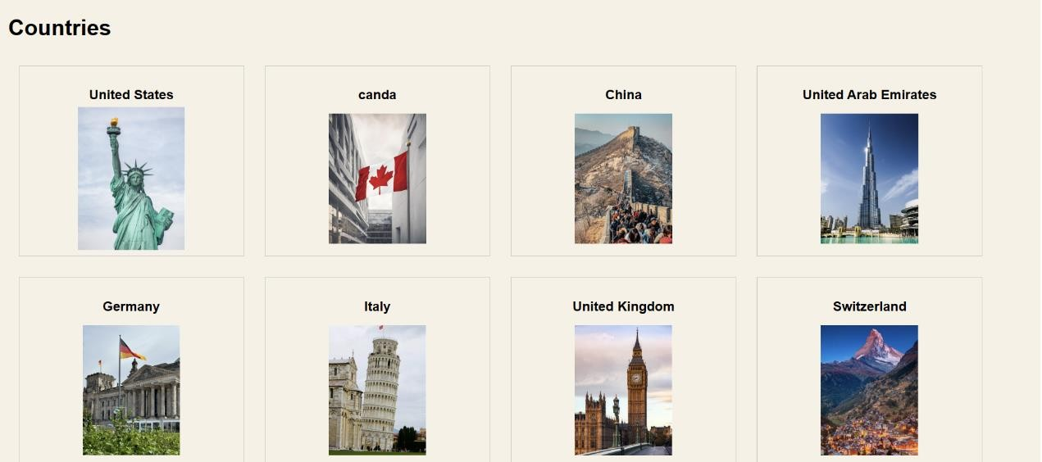

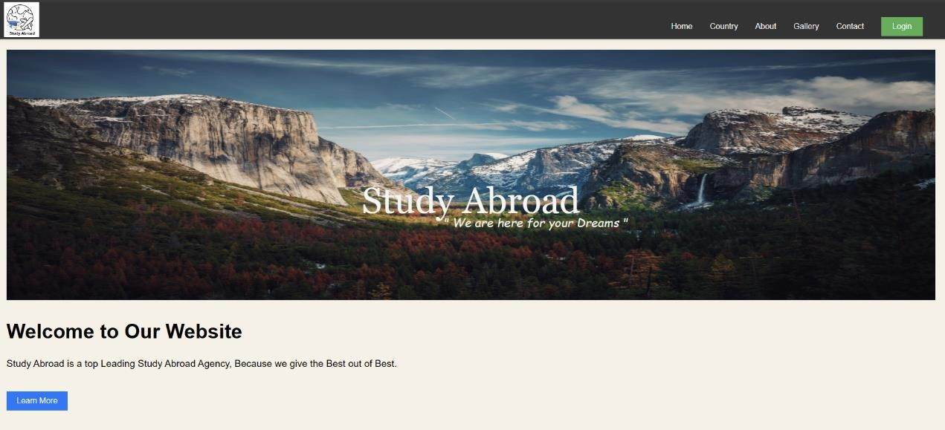

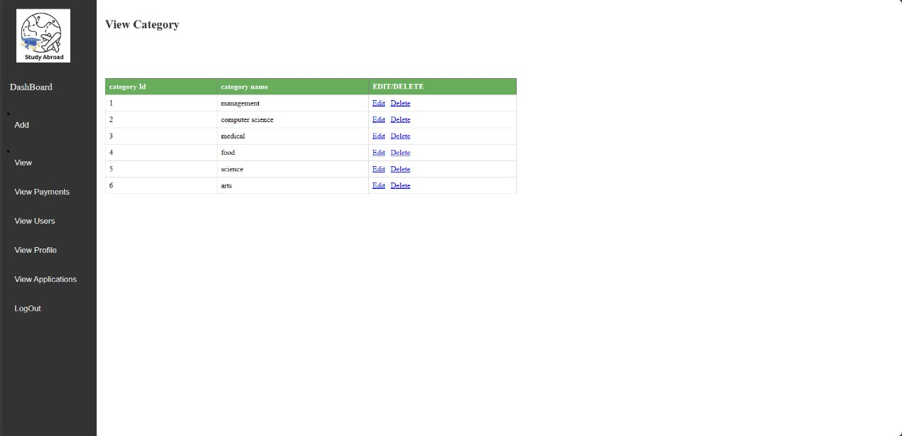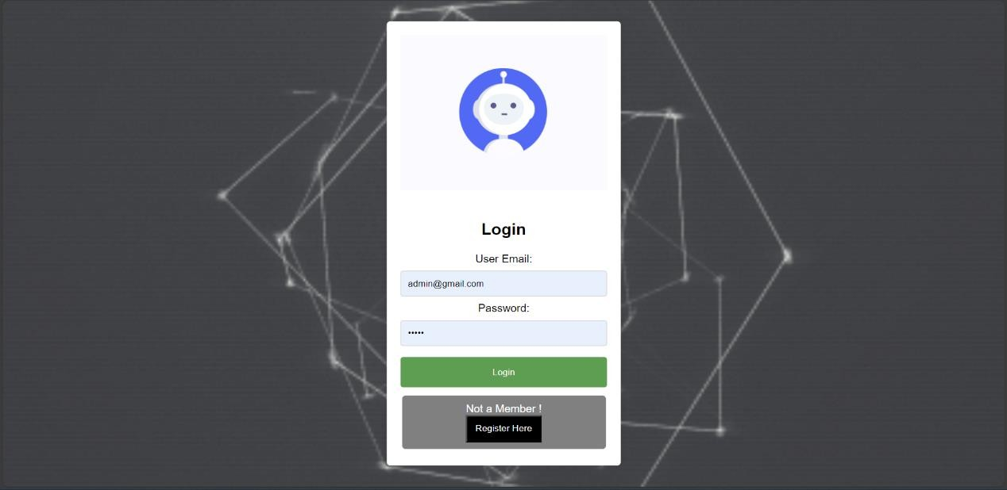

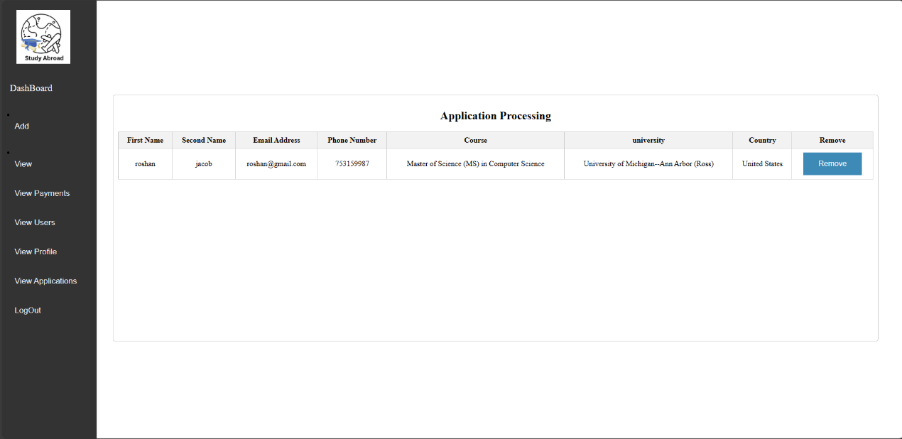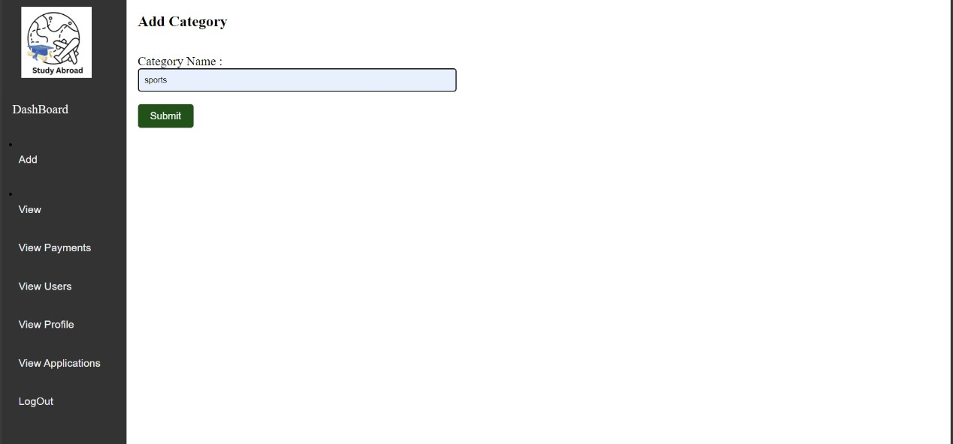

**Code**

### View country

<?php include "header1.php"; include "dbconnect.php"; ?>

<!DOCTYPE html>

<html>

<head>

<title>Country Information</title>

<link rel="stylesheet" href="css/show.css">

</head>

<body>

<h1>Country Information</h1>

<?php

// Fetching data from the table

$query = "SELECT country_name,country_id , image FROM country";

$result = mysqli_query($conn, $query);

// Displaying the data in HTML

while ($row = mysqli_fetch_assoc($result)) { echo '<div class="country">';

echo "<h2>" . $row['country_name'] . "</h2>";

echo "<a href='university.php?country=" . urlencode($row['country_id']) . "'>"; echo "<img src='uploads/" . $row['image'] . "' alt='" . $row['country_name'] . "'

/>";

echo "</a>";

echo '</div>';

}

mysqli_close($conn);

?>

</body>

</html>

### feedback

<?php include "header1.php"; ?>

<!DOCTYPE html>

<html lang="en">

<head>

<meta charset="UTF-8">

<meta name="viewport" content="width=device-width, initial-scale=1.0">

<link rel="stylesheet" href="styles.css">

<title>Feedback Hub</title>

<style>

/* body {

font-family: Arial, sans-serif; margin: 0;

padding: 0;

background-color: #f4f4f4;

} */

.container-feed { max-width: 600px; margin: 50px auto; padding: 20px;

background-color: #fff; border-radius: 8px;

box-shadow: 0 0 10px rgba(0, 0, 0, 0.1);

}

h1 {

text-align: center; margin-bottom: 20px;

}

form {

margin-bottom: 20px;

}

.form-group-feed { margin-bottom: 15px;

}

label {

display: block; margin-bottom: 5px; font-weight: bold;

}

input, select,

textarea { width: 90%; padding: 10px;

border: 1px solid #ccc; border-radius: 5px;

}

.feedbutton button { display: block; width: 100%; padding: 10px;

background-color: #007bff; color: #fff;

border: none; border-radius: 5px; cursor: pointer;

}

.feedbutton button:hover { background-color: #0056b3;

}

</style>

</head>

<body>

<div class="container-feed">

<h1>Feedback Hub & FAQ</h1>

<p>Welcome to our Feedback Hub! We value your thoughts and opinions, and we're dedicated to creating the best experience for our users. Your feedback helps us understand how we can improve and tailor our services to meet your needs. Please take a moment to share your thoughts with us.</p>

<form method="post">

<div class="form-group-feed">

<label for="feedback-type">Feedback Type:</label>

<select id="feedback-type" name="feedback-type">

<option value="general">General Feedback</option>

<option value="bug">Bug Report</option>

<option value="feature">Feature Request</option>

<option value="other">Other</option>

</select>

</div>

<div class="form-group-feed">

<label for="message">Message:</label>

<textarea id="message" name="message" rows="4" ></textarea>

</div>

<button class="feedbutton" type="submit">Submit</button>

</form>

<p>Thank you for taking the time to share your feedback with us. We appreciate your input and will use it to enhance our services. If you have any urgent concerns,

please don't hesitate to contact our support team at <a href=["m](mailto:study_abroad@gmail.com)a[ilto:study_abroad@gmail.com">study_a](mailto:study_abroad@gmail.com)broad@.com</a>.</p>

<p>We look forward to hearing from you and using your feedback to make our services even better!</p>

</div>

<?php

if ($_SERVER["REQUEST_METHOD"] == "POST")

{

include "dbconnect.php"; session_start();

$user_id=$_SESSION['user_id'];

$ftype=$_POST['feedback-type'];

$message=$_POST['message'];

$sql = "INSERT INTO feedback (Type,message,user_id) VALUES ('$ftype', '$message', '$user_id')";

if ($conn->query($sql) === TRUE) { echo "New record created successfully";

} else {

echo "Error: " . $sql . "<br>" . $conn->error;

}

$conn->close();

}

?>

<script>

document.addEventListener("DOMContentLoaded", function() { document.querySelector("form").addEventListener("submit", function(event) { var feedbackType = document.getElementById("feedback-type").value;

var message = document.getElementById("message").value;

if (feedbackType === "" || message === "") { alert("Please fill out all the fields"); event.preventDefault();

}

});

});

</script>

</body>

</html>

### view profile

<?php

include "header1.php"; include "dbconnect.php";

session_start();

$id=$_SESSION["user_id"];

$query = "SELECT u.profile_pic, p.fname, p.lname, p.phone, p.email, DATE_FORMAT(p.dob, '%d/%m/%Y') AS dob, p.gender, p.passport_number, p.university, p.course, p.college, p.percentage, p.certificate

FROM user u

JOIN profile p ON u.user_id = p.user_id WHERE u.user_id = '$id';";

$result = mysqli_query($conn, $query);

if ($result) {

$row = mysqli_fetch_assoc($result);

$profile_pic = $row['profile_pic'];

$fname = $row['fname'];

$lname = $row['lname'];

$phone = $row['phone'];

$email = $row['email'];

$dob = $row['dob'];

$gender = $row['gender'];

$passnum = $row['passport_number'];

$university = $row['university'];

$course = $row['course'];

$college = $row['college'];

$percentage = $row['percentage'];

$certificate = $row['certificate'];

}

?>

<html>

<head>

<style>

body {

font-family: Arial, sans-serif; background-color: #f4f4f4; margin: 0;

padding: 0;

}

.custom-container { max-width: 600px; margin: 20px auto; padding: 20px;

background-color: #fff;

box-shadow: 0 0 10px rgba(0, 0, 0, 0.1); align-items:center;

}

.custom-form-group { margin-bottom: 20px; padding-left:30px;

}

.custom-label { display: block; margin-bottom: 5px;

}

.custom-input { width: 100%; padding: 10px;

border: 1px solid #ccc; border-radius: 5px;

box-sizing: border-box;

}

.custom-radio-group { width: 100%; padding: 10px;

border: 1px solid #ccc; border-radius: 5px;

box-sizing: border-box;

}

#custom-form-group2 a {

background-color: #4CAF50; color: white;

padding: 14px 269px;

border: none; border-radius: 5px; cursor: pointer; font-size: 16px;

text-decoration: none; /* Added to remove underline from the anchor */

}

#custom-form-group2 a:hover { background-color: #45a049;

}

#custom-form-group2 a { margin-top:10px;

}

#custom-form-group a {

background-color: #2e9dd4; color: white;

padding: 14px 200px; border: none;

border-radius: 5px; cursor: pointer; font-size: 16px;

text-decoration: none; /* Added to remove underline from the anchor */

}

#custom-form-group a:hover { background-color: #1c7dab;

}

.profile-photo { width: 350px; height: 350px; align-items:center; margin-left:100px; object-fit: cover;

border-radius: 70%; /* Create a circular shape */

box-shadow: 0 0 10px rgba(0, 0, 0, 0.1); /* Add a subtle shadow effect */

}

.custom-form-group-update{ background-color: #7F00FF; border: none;

color: white; padding: 10px 40px; text-align: center; text-decoration: none; display: inline-block; font-size: 16px;

margin: 4px 2px; cursor: pointer; border-radius: 5px;

}

/* Add this CSS code to your style.css file */

.table-container { margin-top: 20px;

}

.custom-table { width: 100%;

border-collapse: collapse;

}

.custom-table td { padding: 8px; text-align: left; border: none;

}

</style>

</head>

<body>

<div class="custom-container">

<h2>Profile Information</h2>

<form action="profile.php" method="post">

<div class="custom-form-group">

<a href="../profile<?php echo $profile_pic; ?>" target="_blank">

<img class="profile-photo" src="../profile/<?php echo $profile_pic; ?>" alt="User Profile Photo">

</a>

</div>

<div class="table-container">

<table class="custom-table">

<tr>

<td>First Name:</td>

<td><?php echo $fname; ?></td>

</tr>

<tr>

<td>Last Name:</td>

<td><?php echo $lname; ?></td>

</tr>

<tr>

<td>Phone:</td>

<td><?php echo $phone; ?></td>

</tr>

<tr>

<td>Email:</td>

<td><?php echo $email; ?></td>

</tr>

<tr>

<td>Date of Birth:</td>

<td><?php echo $dob; ?></td>

</tr>

<tr>

<td>Gender:</td>

<td><?php echo $gender; ?></td>

</tr>

<tr>

<td>Passport Number:</td>

<td><?php echo $passnum; ?></td>

</tr>

<tr>

<td>University Studied:</td>

<td><?php echo $university; ?></td>

</tr>

<tr>

<td>College Studied:</td>

<td><?php echo $college; ?></td>

</tr>

<tr>

<td>Course:</td>

<td><?php echo $course; ?></td>

</tr>

<tr>

<td>Percentage:</td>

<td><?php echo $percentage; ?></td>

</tr>

</table>

</div>

<div class="custom-form-group">

<label class="custom-label">Certificate Attached:</label>

<a href="../user/<?php echo $certificate; ?>" target="_blank">

<button type="button">View Certificate</button>

</a>

</div>

<?php

$query="SELECT course from payment where user_id='$id'";

$result = mysqli_query($conn, $query);

if ($result) {

$row = mysqli_fetch_assoc($result);

$course=$row['course'];

}

$query="SELECT course_name from course where course_id='$course'";

$result = mysqli_query($conn, $query); if ($result) {

$row = mysqli_fetch_assoc($result);

?>

<label class="custom-label">Course Applied : <?php echo $row['course_name'];

;?></label>

<?php

}

?>

<a href="updateprofile.php">

<div class="custom-form-group-update"> Update Profile

</div>

</a>

<a href="updateprofile_pic.php">

<div class="custom-form-group-update"> Update Profile Picture

</div>

</a>

</body>

### Add course

<?php

require('../config/autoload.php'); include("header1.php");

$msg="";

$elements=array( "course_name"=>"", "duration"=>"",

"syllabus"=>"", "eligibility"=>"", "criteria"=>"",

"status"=>"",

"amount"=>"", "university_id"=>"", "category_id"=>"", "country_id"=>"", );

$form=new FormAssist($elements,$_POST);

$file=new FileUpload();

$dao=new DataAccess();

$labels=array('course_name'=>"Course Name", 'duration'=>"Course Duration", 'syllabus'=>"Syllabus", 'eligibility'=>"Course eligibility", 'criteria'=>"criteria", 'status'=>"status", 'amount'=>"amount", 'university_id'=>"University ID", 'category_id'=>"Category ID", 'country_id'=>"Country ID",);

$rules=array( "course_name"=>array("required"=>true,"minlength"=>2,"maxlength"=>50,),

"duration"=>array("required"=>true,"minlength"=>1,"maxlength"

=>2,),

"syllabus"=> array('filerequired'=>true), "eligibility"=>array("required"=>true,"minlength"=>2,"maxlength"=>30,), "criteria"=>array("required"=>true,"minlength"=>2,"maxlength"=>30,), "status"=>array("required"=>true,"minlength"=>2,"maxlength"=>30,), "amount"=>array("required"=>true,"maxlength"=>9,"integeronly"=>true,), "country_id"=>array("required"=>true), "university_id"=>array("required"=>true),

"category_id"=>array("required"=>true),

);

$validator = new FormValidator($rules,$labels);

if(isset($_POST["btn_insert"]))

{

if($validator->validate($_POST))

{

if($fileName=$file-

>doUploadRandom($_FILES['syllabus'],array('.pdf'),100000,1,'../uploads'))

{

$data=array(

'course_name'=>$_POST['course_name'], 'duration'=>$_POST['duration'],

'syllabus'=>$fileName, 'eligibility'=>$_POST['eligibility'], 'criteria'=>$_POST['criteria'], 'status'=>$_POST['status'], 'amount'=>$_POST['amount'], 'university_id'=>$_POST['university_id'],

'category_id'=>$_POST['category_id'],

'country_id'=>$_POST['country_id'],

);

//print_r($data);

if($dao->insert($data,"course"))

{

echo "<script> alert('New record created successfully');</script> "; header('location:course.php');

}

else

{$msg="Registration failed";} ?>

<span style="color:red;"><?php echo $msg; ?></span>

<?php

}

}

}

?>

<html>

<head>

</head>

<body>

<form action="" method="POST" enctype="multipart/form-data" >

<h2 class="row" >Add Course</h2>

<div class="row">

<div class="col-md-6"> Course Name :

<?= $form->textBox('course_name',array('class'=>'form-control')); ?>

<?= $validator->error('course_name'); ?>

</div></div>

<div class="row">

<div class="col-md-6"> Course Duration :

<?= $form->textBox('duration',array('class'=>'form-control')); ?>

<?= $validator->error('duration'); ?>

</div></div>

<div class="row">

<div class="col-md-6"> Course Syllabus :

<?= $form->fileField('syllabus',array('class'=>'form-control')); ?>

<span style="color:red;"><?= $validator->error('syllabus'); ?></span>

</div>

</div>

<div class="row">

<div class="col-md-6"> Course Eligibility :

<?= $form->textBox('eligibility',array('class'=>'form-control')); ?>

<?= $validator->error('eligibility'); ?>

</div></div>

<div class="row">

<div class="col-md-6"> Course Criteria:

<?= $form->textBox('criteria',array('class'=>'form-control')); ?>

<?= $validator->error('criteria'); ?>

</div></div>

<div class="row">

<div class="col-md-6"> Course status :

<?= $form->textBox('status',array('class'=>'form-control')); ?>

<?= $validator->error('status'); ?>

</div></div>

</div>

<div class="row">

<div class="col-md-6"> Course Payment :

<?= $form->textBox('amount',array('class'=>'form-control')); ?>

<?= $validator->error('amount'); ?>

</div></div>

</div>

<div class="row">

<div class="col-md-6"> Country name:

<?php

$options = $dao->createOptions('country_name','country_id',"country"); echo $form->dropDownList('country_id',array('class'=>'form-

control'),$options); ?>

<?= $validator->error('country_id'); ?>

</div>

</div>

</div> <div class="row">

<div class="col-md-6"> Category name:

<?php

$options = $dao->createOptions('category_name','category_id',"category");

echo $form->dropDownList('category_id',array('class'=>'form-control'),$options);

?>

<?= $validator->error('category_id'); ?>

</div>

</div>

<div class="row">

<div class="col-md-6"> University name:

<?php

$options = $dao->createOptions('university_name','university_id',"university"); echo $form->dropDownList('university_id',array('class'=>'form-

control'),$options); ?>

<?= $validator->error('university_id'); ?>

</div>

<br><br>

<button type="submit" name="btn_insert" >Submit</button>

</form>

</body>

</html>

### view university

<?php include "header1.php"; include "dbconnect.php"; ?>

<!DOCTYPE html>

<html>

<head>

<title>University Information</title>

</head>

<body>

<?php

// Retrieve the ID from the URL

$id=0;

$id = $_GET['country'];

// Fetching data from the table

$query = "SELECT university_name,university_id , uimage,location FROM university WHERE country_id = $id";

$result = mysqli_query($conn, $query);

// Displaying the data in HTML

while ($row = mysqli_fetch_assoc($result)) { echo '<div class="country">';

echo "<h2>" . $row['university_name'] . "</h2>";

echo "<a href='course.php?university=" . urlencode($row['university_id']) . "'>";

echo "<img src='uploads/" . $row['uimage'] . "' alt='" . $row['university_name'] . "'

/>";

echo "</a>";

echo "<p>" . $row['location'] . "</p>"; echo '</div>';

}

// Close connection mysqli_close($conn);

?>

</body>

</html>